



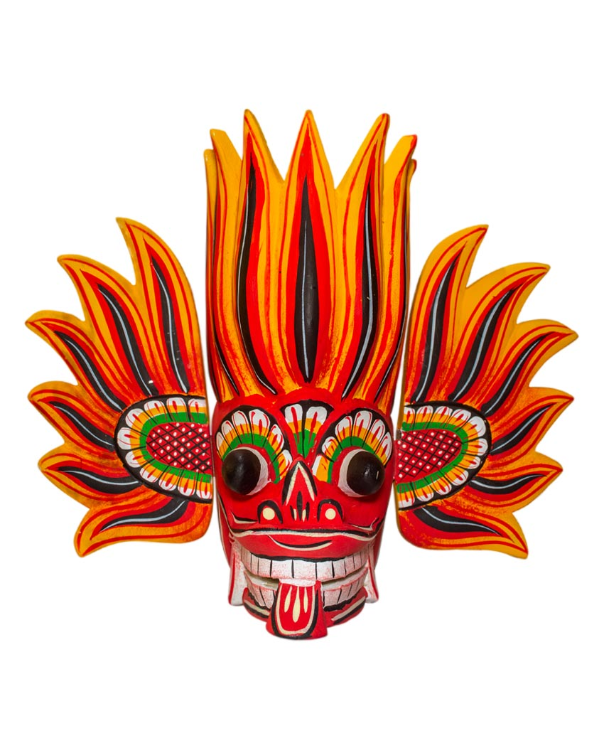

**Devil Dance**

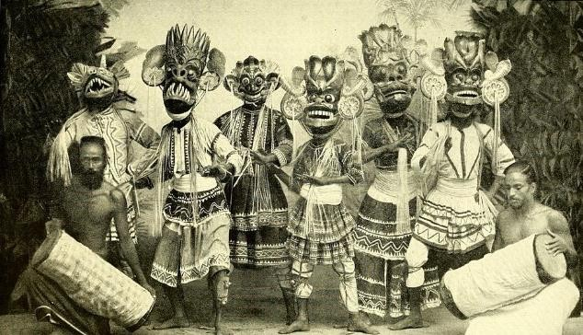

The "Devil Dances" are an attempt to respond to the common belief that certain ailments are caused by unseen hands and that they should be chased away for the patient to get cured. If an individual or a family is not doing well, the village-folk believe that it's because that person or the family is being harassed by unseen hands. A 'tovil' ceremony is the answer.

The 'tovil' can be a simple ritualistic ceremony at home restricted to

family and immediate neighbours or involving the whole village like the 'gam- maduva' or the 'devol-maduva' which is closely linked to the worship of gods. Masked dancers take part in at least two of the well-known 'tovil' ceremonies referred to as the 'Maha Sohon Samayama' and the 'Gara Yakuma'. The mention of 'Maha Sohona' frightens the people since he is believed to be the demon of the graveyards.



**Name : MUHAMMAD SAMI ULLAH ………………….  
FATHER NAME : AHSAN ULLAH …………………  
PHONE NO. : 03278278707**

The performer disguises himself as a bear and wears a mask and a dress to resemble one. Often the 'tovil' involves the 'sanni' dances where all the dancers wear masks. The 'daha ata sanniya' refers to eighteen ailments with a demon being responsible for each one of them.